

WALKRHOUGH GUIDE
INTRODUCTION
Walkthrough Guide

This is where the name of the tools would be introduce

Everything about the tools could be covered here.

Margins:
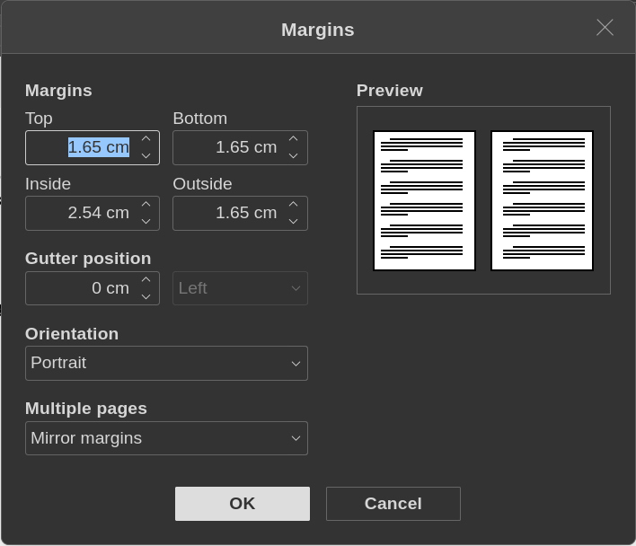
Table of Contents
Heading 1 – Tool name 1 - Tools 4
Heading 2 – Tools requirements 4
Heading 3 – Step by Step Demonstration 4
Heading 4 – Key point to Highlight 4
CSI TorVPN 1 - Tools 5
Tools requirements 5
Step by Step Demonstration 5
Heading 4 – Key point to Highlight 5
CSI Linux Management 1 - Tools 6
Tools requirements 6
Step by Step Demonstration 6
Heading 4 – Key point to Highlight 6
TorBrowser 1 - Tools 7
Tools requirements 7
Step by Step Demonstration 7
Heading 4 – Key point to Highlight 7

TOOL-1


Heading 1 – Tool name 1 - Tools

This is the 8 x 11 Basic Template. Paste your manuscript into this template or simply start typing. Delete this text prior to use.

Heading 2 – Tools requirements
This is testing the Normal paragraph setting after pressing Enter from Heading 2.

Here’s the example code text:

Heading 3 – Step by Step Demonstration
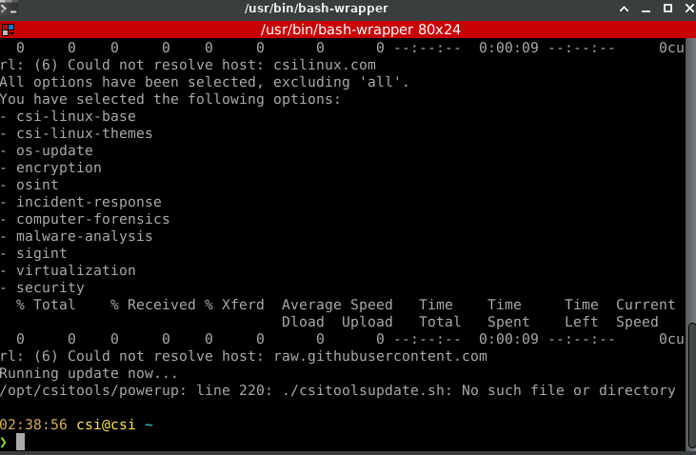
<<Pictures view>>

Heading 4 – Key point to Highlight
Summary & Troubleshooting
Command source (Lucida Console 9)

Note (Bookerly 11)

TOOL-2

CSI TorVPN 1 - Tools

This is the 8 x 11 Basic Template. Paste your manuscript into this template or simply start typing. Delete this text prior to use.

Tools requirements
This is testing the Normal paragraph setting after pressing Enter from Heading 2.

Here’s the example code text:

Step by Step Demonstration
<<Pictures view>>

Heading 4 – Key point to Highlight
Summary & Troubleshooting
Command source (Lucida Console 9)

Note (Bookerly 11)

TOOL-2

CSI Linux Management 1 - Tools

This is the 8 x 11 Basic Template. Paste your manuscript into this template or simply start typing. Delete this text prior to use.

Tools requirements
This is testing the Normal paragraph setting after pressing Enter from Heading 2.

Here’s the example code text:

Step by Step Demonstration
<<Pictures view>>

Heading 4 – Key point to Highlight
Summary & Troubleshooting
Command source (Lucida Console 9)

Note (Bookerly 11)

TorBrowser 1 - Tools

This is the 8 x 11 Basic Template. Paste your manuscript into this template or simply start typing. Delete this text prior to use.

Tools requirements
This is testing the Normal paragraph setting after pressing Enter from Heading 2.

Here’s the example code text:

Step by Step Demonstration

Heading 4 – Key point to Highlight
Summary & Troubleshooting
Command source (Lucida Console 9)

Note (Bookerly 11)

